Report 1: Parallel Activation Calibration
Nov 2, 2026 · Bryan Palom, Marco Carreno
This report parallelizes per-layer INT8 activation calibration for ResNet-20 on CIFAR-10, in CUDA (P1) and MPI (P2), and compares four threshold methods on speed and accuracy. On the largest layers P1 is 413× faster than one CPU thread and P2 is 18× faster on 22 cores; every method keeps accuracy within 0.2 points of FP32.

1. Problem
Storing each layer's input activations as 8-bit integers needs one clipping threshold T per layer, and choosing T is the work parallelized here. A value x becomes q = clamp(round(x / s), -127, 127) with scale s = T / 127. Values above T are clipped, and values below it share 127 equal steps.
- Model: a pretrained ResNet-20 from akamaster/pytorch_resnet_cifar10, with a reported top-1 accuracy of 91.73%. BatchNorm is folded into the convolutions.
- Layers: 19 convolutions and 1 fully connected layer. Layer 00's input is the image itself, so 19 layers are calibrated.
- Data: 512 CIFAR-10 training images, shuffled with seed 0, for calibration. All 10,000 test images for accuracy.
Layers | Input per image | Values per image | Values at 512 images
01 to 07 | 16 × 32 × 32 | 16,384 | 8,388,608
08 to 13 | 32 × 16 × 16 | 8,192 | 4,194,304
14 to 18 | 64 × 8 × 8 | 4,096 | 2,097,152
19 (FC) | 64 | 64 | 32,768
Across all 19 layers that is 184,384 values per image, or 94.4 million at 512 images. Every method reads all of them once to build a histogram, and the search methods then score 1,921 candidate thresholds per layer.

2. Algorithms
All four methods share one pass over the data and differ only in how they pick T from a histogram. For each layer:
- Range: find m = max |x|.
- Histogram: count |x| into 2,048 bins of width w = m / 2,048.
- Search: score candidate cut-offs at bins i = 128 to 2,048, which gives 1,921 candidates. The smallest is 128 because 128 levels need at least 128 bins.
- Choose: take the lowest score and convert its bin to T.
Method | Picks the T that | T from the chosen bin | Work after the histogram
Max | never clips | T = m | None
Percentile | keeps a fraction q of values in range, for q from 99.9% to 99.9999% | (bin + 1) · w | One prefix sum over 2,048 bins
MSE | minimizes mean squared error between values and their quantized versions | i · w | 1,921 candidates × 2,048 bins
KL | best preserves the shape of the distribution after clipping and merging into 128 levels | (i + 0.5) · w | 1,921 candidates × up to 2,048 bins
Three details differ from the textbook versions:
- Zero spike in KL: after a ReLU, often half of all values are exactly 0, all in bin 0. Left alone, that spike pins KL at the smallest candidate on every layer. Bin 0 is scored with bin 1's count. On synthetic ReLU-like data this moved T from about 2 to about 6, against a 99.99th percentile of about 9.
- Empty bins in KL: only a q of exactly 0 is replaced by a small ε, so real small probabilities are not raised.
- MSE threshold: T = i · w. The half-bin offset belongs to KL only.
An optional smoothing step can run between the histogram and the KL and MSE searches. It averages sparse tail bins with their neighbours, leaves bin 0 untouched, and keeps the total count. Section 8 tests whether it makes T more stable.

3. Data structures
The large array is read once, and everything after the histogram works on 2,048 bins, so the search fits in a few kilobytes.
(CUDA)
Name | Type and size | Memory | Purpose
x | float[n], up to 8.4M | Global | One layer's activations
d_max_bits | int | Global | m as float bits, for atomicMax
s_hist | uint32[2,048], 8 KB | Shared, one per block | Private histogram
d_hist | uint32[2,048] | Global | Merged histogram
d_smooth | float[2,048] | Global | Histogram read by KL and MSE, smoothed or a plain copy
d_score | float[1,921] | Global | One KL or MSE score per candidate
s_gsum, s_gnz | float[128], int[128] | Shared, one per search block | Level totals and non-empty bin counts for one KL candidate
s_red | float[32] | Shared | One partial sum per warp for block reductions
d_best, d_bin | int | Global | Winning candidate and percentile bins
(MPI)
- Images: rank r owns images r·N/p to (r+1)·N/p. The activation files are stored image by image, so each share is one contiguous slice read with MPI_File_read_at, with no communication.
- Histogram: each rank builds a local uint32[2,048] histogram (8 KB), the same type as P1's. The allreduce sums them, and every rank gets the full copy.
- Candidates: split cyclically, so candidate c goes to rank c mod p. A KL candidate's cost grows with i, so a block split would give the last rank the most expensive candidates.
- Percentile: computed on every rank. Scanning 2,048 bins is cheaper than sending a message.

4. Communication pattern
MPI implementation sends three kinds of small collective per layer, and none of them grows with the number of images. The largest message is the 8 KB histogram, and the three together take under 0.1 ms at every p (section 8).
Step | Call | Message size | Rounds
Global max | MPI_Allreduce with MPI_MAX | 1 float | log p
Merge histograms | MPI_Allreduce with MPI_SUM | 2,048 uint32, 8 KB | log p, or a ring for long messages
Pick the best threshold | MPI_Allreduce with MPI_MINLOC on (score, index) | 2 (score, index) pairs: KL and MSE in one call | log p
The second allreduce must wait for the first, because the bin width depends on the global max. Smoothing, when used, runs on every rank after the histogram allreduce and adds no messages.
Batching every layer's histogram into one allreduce of 19 × 2,048 words would pay the latency once instead of 19 times. It was not measured, because communication is already under 1.5% of P2's time.

5. Contention and synchronization
The histogram is the one place where many GPU threads write the same addresses, and the ReLU spike makes bin 0 the worst of them.
Where | Kind | Severity | Mitigation
Histogram bins | Write: atomicAdd collisions | High, because half or more of all values are often exactly 0 | Private shared-memory histogram per block, then one atomic per warp for zeros
Histogram merge | Write: global atomics | Low: at most 2,048 per block, mostly to different bins | Skip empty bins
Abs-max | Write: atomicMax | Low: one per warp | Warp reduction first
Search reads | Read: all 1,921 blocks read the same 8 KB | Low: served from L2 cache | Optionally stage in shared memory
Measured histogram cost
The amount of contention is measured against a baseline that has as much of it as possible. In the global-atomics version, all 8.4 million increments are atomics on the same 2,048 global counters, so it is the worst case. Each later version removes one source of collisions, and the time it saves is the cost of that source. The baseline is also the simplest correct histogram, so the faster versions are checked against it bin for bin.
Layer (values at 512 images) | Global atomics (ms) | Shared, per block (ms) | Shared + warp-aggregated zeros (ms) | Global / shared
01 (8.4M) | 1.611 | 0.046 | 0.049 | 35×
08 (4.2M) | 1.166 | 0.027 | 0.029 | 43×
14 (2.1M) | 0.659 | 0.018 | 0.019 | 37×
19, FC (33K) | 0.008 | 0.006 | 0.006 | 1.2×
Times are GPU events with a cold L2 cache, mean of 10 runs. Across the 18 convolution layers, private shared-memory histograms are 22 to 58× faster than global atomics. The global-atomic time varies from 0.99 to 2.58 ms between layers of the same size, following how many values are exactly zero, so the bin-0 collisions are most of its cost. Aggregating the zeros per warp is slower on every layer, by 4 to 8%: on this GPU, shared-memory atomics are cheap enough that the extra ballot and population count cost more than the collisions they remove. The FC layer is too small for contention to matter.
Synchronization happens in four places:
- Kernel boundaries: each kernel waits for the previous one. Each costs about 4 µs: smooth, both argmins and the percentile take 4 to 12 µs although they do almost no work, so these fixed costs are a third of the pipeline on small layers.
- Host copy: the host reads m back once per layer before launching the histogram.
- Block barriers: 7 per KL candidate (three block sums with two each, plus one after the group totals) and 2 per MSE candidate, and none between blocks.
- Warp shuffles: used inside every reduction, with no barrier needed.

6. Parallel time complexity
The data pass shrinks as more workers are added, but the search costs about 3.9 million bin visits per layer whatever the layer's size. Small layers therefore stop scaling first.
Notation: n = activations in one layer; C = 1,921 candidates; P = GPU threads running at once; p = MPI ranks; t_c = time per operation; t_s = message latency; t_w = time per 32-bit word.
(CUDA)
$$T_{P1}≈\frac{2n}{P} c_{\text{contention}}+\frac{2048 C}{\min\left(P, 256 C\right)}+\text{kernel boundaries}$$
The contention factor c is 1 when no atomics collide and grows with the size of the zero spike. The search can use at most C = 1,921 blocks, and the argmin takes log C steps.
(MPI)
$$T_{P2}\left(p\right)≈\frac{\left(2n+2048 C\right) t_{c}}{p}+\log_{2}{p} \left(3 t_{s}+2053 t_{w}\right)$$
The 2,053 words are 1 for the max, 2,048 for the uint32 bins and 4 for the two MINLOC pairs. Computation falls as 1/p while communication grows only as log p, so speedup should stay close to linear until n/p becomes small.
- Constants: estimated from the measured allreduces at 22 ranks rather than a separate ping-pong test. The 1-float max takes 5.1 µs, so t_s ≈ 1.1 µs; the 8 KB histogram takes 31 µs, so t_w ≈ 2.9 ns per word.
- Prediction at 22 ranks, layer 01: 54.5 ms / 22 = 2.48 ms of computation plus 42 µs of communication, a speedup of 21.6×. The measured 3.03 ms (18.0×) is 20% slower.
- Where it departs: every phase runs about 20% slower than 1/p at 22 ranks, including the search, which touches only 8 KB. That points to the lower all-core clock speed, not to memory or messages; the model's fixed t_c does not hold when all cores are busy.
- Crossover: with these constants, communication would equal computation only near 700 ranks, far beyond one node.
- P1: the data-pass term 2n/P matches the measured times up to 64 blocks, then memory bandwidth takes over (section 8). The search term is constant because 1,921 blocks already fill the GPU.

7. Timing experiments
Each GPU time is the mean of 10 runs after one discarded warm-up, each CPU time the mean of 3 runs after a warm-up, and each MPI time the mean of 5 runs after a warm-up. Every program checks its chosen bins against the one-thread CPU version before any time is recorded. All experiments run from one script, scripts/run_experiments.sh, one after another on an otherwise idle server.
Setup
Item | Value
GPU | NVIDIA RTX PRO 5000 Blackwell: 110 SMs, 48 GB, 96 MB L2 cache
CUDA | 12.8 (nvcc), driver 580.126
CPU | Intel Xeon w7-2575X: 22 cores, 44 hardware threads, one socket, 45 MB L3 cache
Compilers | g++ 13.3 with -O3 for host code and P2; nvcc -O3 -arch=native for kernels
MPI | Open MPI 4.1.6
Interconnect | None: one node, so ranks communicate through shared memory
OS | Ubuntu 24.04.5
Method
- GPU: cudaEventRecord between steps, so each step's time is measured by the GPU itself. Before each run the program writes a 192 MB buffer, twice the L2 cache, so no run reads the layer from cache left by the previous one. The upload to the GPU is reported separately.
- CPU baseline: the whole algorithm on one thread, compiled by g++ -O3 with the same code P2 runs with one rank. Built through nvcc, the same loops ran up to 2× slower, which would have inflated every speedup.
- MPI: MPI_Barrier, then MPI_Wtime around each phase, reporting the slowest rank. Ranks are bound one per core up to 22, then to hardware threads.
- Baselines: P1 against the one-thread CPU version and against 1 block; P2 against 1 rank, whose 54.5 ms on layer 01 is within 4% of the CPU baseline's 52.2 ms.
Run matrix
Program | Varied | Range | Held fixed
P1 | Layer | All 19 | 512 images, full grid
P1 | Thread blocks for absmax and histogram | 1, 2, 4, ... 512, 660 (the full GPU) | Layer 01, 512 images, 256 threads per block
P1 | Calibration images | 512, 1,024, 2,048, 4,096 | Layer 01
P1 | Histogram version | Global atomics, shared, shared + warp-aggregated zeros | All 19 layers, 512 images
P2 | Ranks, strong scaling | 1, 2, 4, 8, 16, 22 cores, then 32 and 44 hardware threads | Layers 01, 08, 14 and 19 at 512 images; layer 01 at 4,096
P2 | Ranks, weak scaling | Same | Layer 01, 64 images per rank
P1 | Smoothing radius | 0, 2, 4, 8 | 8 disjoint subsets each of 32, 64, 128 and 512 images; layers 01, 08, 14, 19
Both | Thresholds for accuracy | 7 methods, plus KL and MSE at 3 smoothing radii | 512 images; 10,000 test images

8. Performance results
Every correctness check passed. On layer 01 the GPU pipeline takes 0.126 ms against 52.2 ms on one CPU thread, 413× faster; P2 reaches 18.0× on 22 cores. Every INT8 method stays within 0.2 points of FP32 accuracy.
P1 (CUDA)
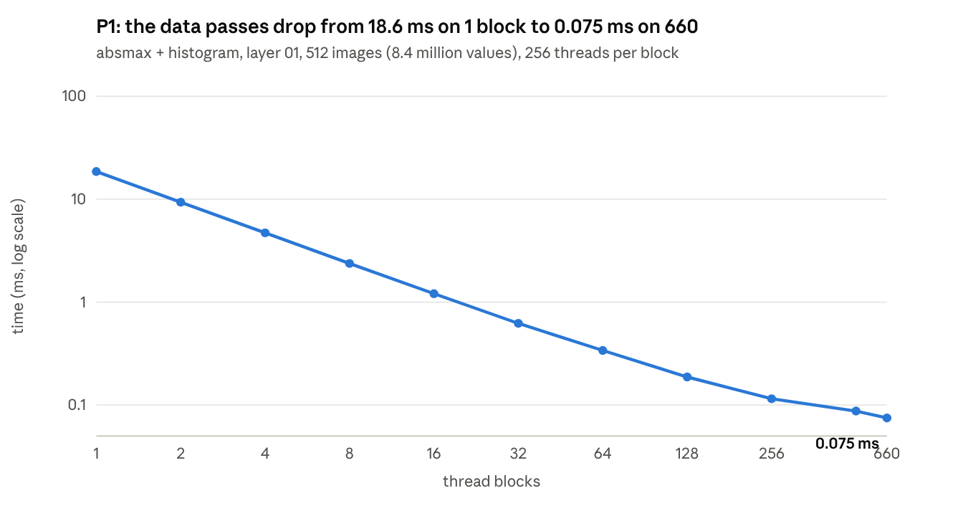
results/raw/p1_grid.txt · RTX PRO 5000 Blackwell · CUDA events, mean of 10 runs after a warm-up, L2 flushed
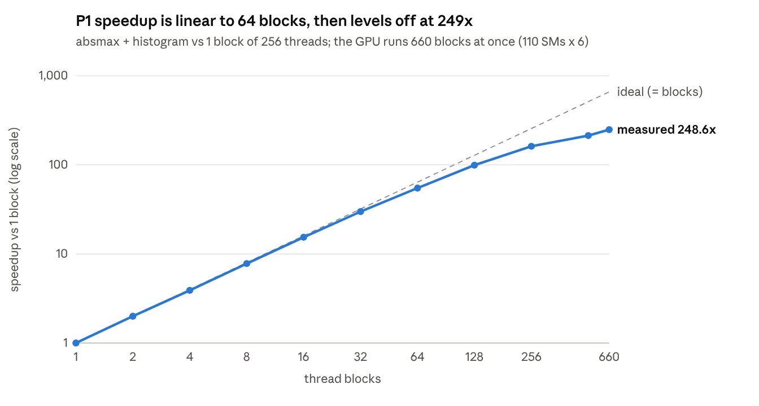
results/raw/p1_grid.txt · speedup = time on 1 block / time on b blocks
The two passes over the data scale almost perfectly up to 64 blocks (16,384 threads), then flatten as they reach the GPU's memory bandwidth: at 660 blocks they read the 33.5 MB layer twice in 0.075 ms. The searches always launch one block per candidate, so the grid size does not change them.
Per step on layer 01 at 512 images, against one CPU thread:
Step | GPU (ms) | CPU (ms) | Speedup
absmax | 0.052 | 7.13 | 138×
histogram | 0.024 | 7.60 | 319×
smooth | 0.004 | 0.003 | 0.8×
MSE search | 0.008 | 13.81 | 1,686×
argmin, MSE | 0.004 | 0.002 | 0.4×
KL search | 0.018 | 23.65 | 1,283×
argmin, KL | 0.004 | 0.002 | 0.4×
percentile | 0.012 | 0.003 | 0.3×
Total | 0.126 | 52.20 | 413×
The searches gain the most, because 1,921 blocks score all candidates at once. The four one-block steps are slower than the CPU: a kernel launch alone costs about 4 µs, more than the CPU needs for 2,048 bins. Across all 19 layers the GPU pipeline takes 0.078 to 0.128 ms and runs 391 to 456 times faster than one CPU thread.
With more calibration images the speedup over one CPU thread falls, from 417× at 512 images to 266× at 4,096 (0.594 ms against 158 ms on layer 01). The search costs the same at any size, so the data passes, which gain less on the GPU (about 190× against 1,300× or more for the searches), make up more of the work.
P2 (MPI)
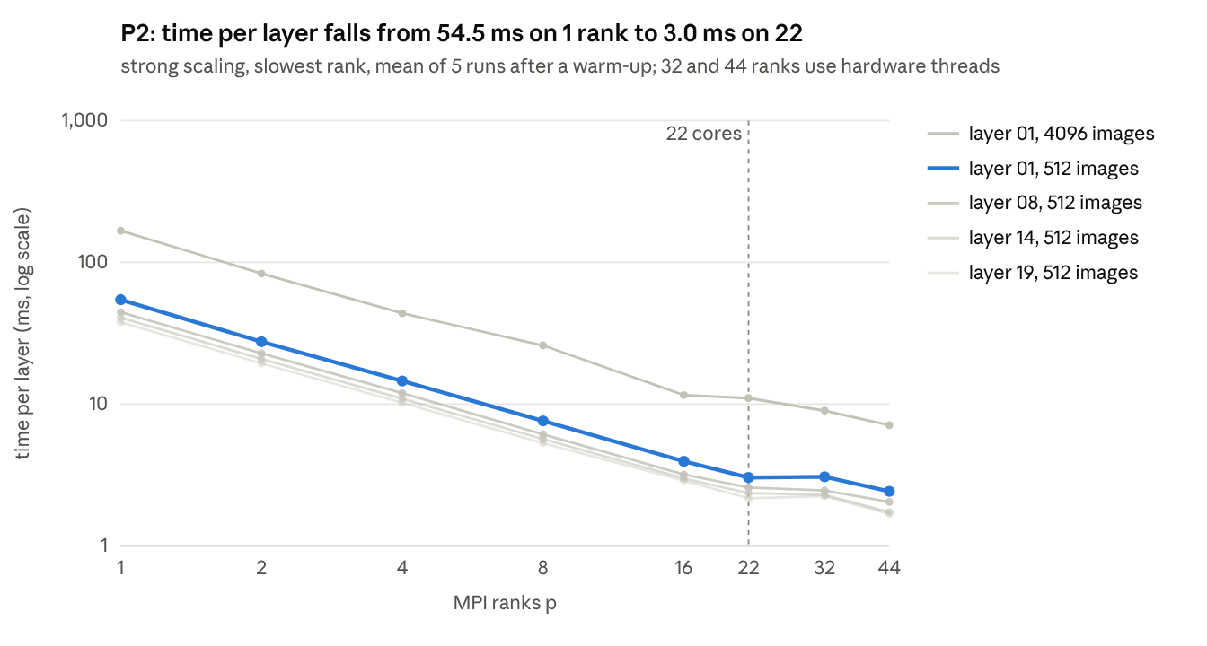
results/raw/p2_strong.txt · Xeon w7-2575X, 22 cores · Open MPI 4.1.6, one node
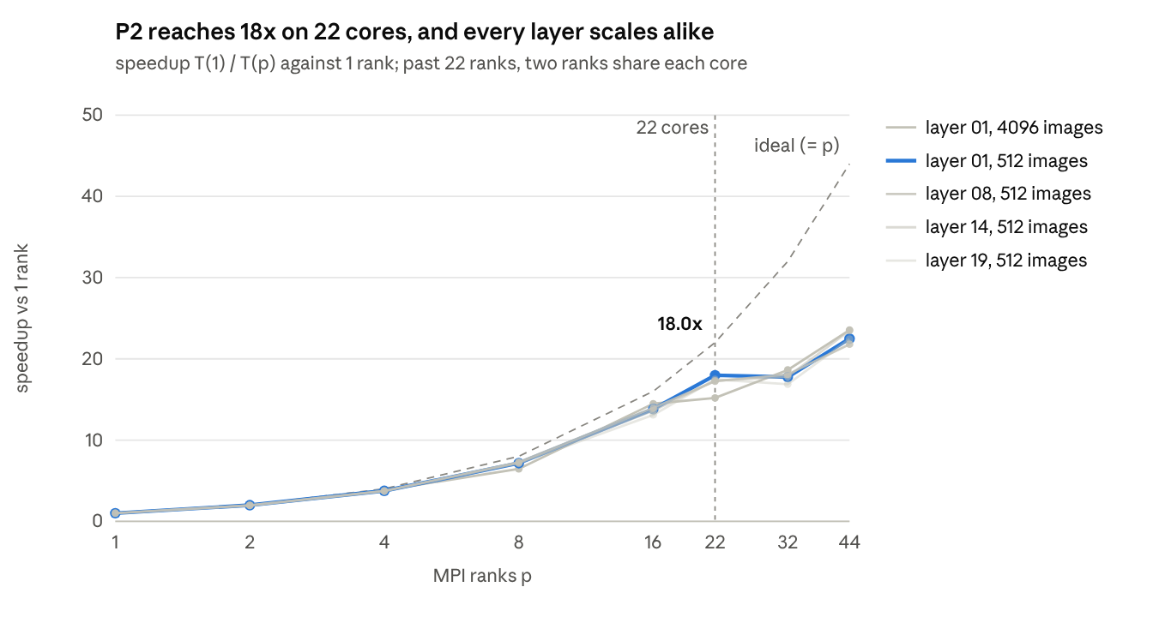
results/raw/p2_strong.txt · speedup = time on 1 rank / time on p ranks
Every p gave identical thresholds on every layer. Speedup stays close to linear up to 16 ranks (86% efficiency on layer 01) and reaches 18.0× on all 22 cores (82%). Past 22 ranks two ranks share each core through hyperthreading, which adds little: 22.5× at 44. The four layers scale alike because the search, the largest phase, does the same 1,921 candidates on every layer.
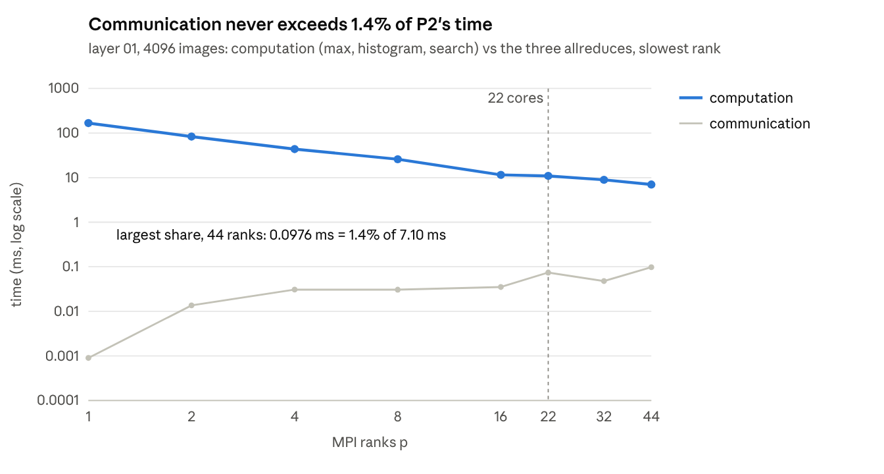
results/raw/p2_strong.txt · each phase timed between barriers, slowest rank
The three allreduces never take more than 0.1 ms, so P2's limit is computation, not messages. Past 16 ranks every phase runs about 20% slower than a perfect 1/p split, the search included, which points to the CPU's lower clock speed when all cores are busy (section 6).
Weak scaling (layer 01, 64 images per rank). Only the passes over the data have fixed work per rank; the search does the same 1,921 candidates at every p, so it keeps shrinking as 1/p and is shown on its own.
Ranks | Images | Max + histogram (ms) | Efficiency | Search (ms)
1 | 64 | 1.880 | 100% | 39.88
2 | 128 | 1.886 | 100% | 20.17
4 | 256 | 2.611 | 72% | 10.46
8 | 512 | 2.105 | 89% | 5.43
16 | 1,024 | 2.109 | 89% | 2.81
22 | 1,408 | 2.739 | 69% | 2.17
32 | 2,048 | 3.349 | 56% | 2.25
44 | 2,816 | 3.794 | 50% | 1.65
The data passes keep about 89% efficiency to 16 ranks, apart from one noisy point at 4, and drop to 50% at 44 ranks, where hardware threads share each core's memory bandwidth.
Accuracy
No method is measurably better than the others: all seven land between 91.54% and 91.82%, and with 10,000 test images one standard error is about 0.27 points. Weights stay FP32, every calibrated layer's input is quantized to INT8 with that method's T, and layer 00's input (the image) stays FP32.
Activations | Test accuracy (%) | Change from FP32 (points)
FP32 | 91.73 | 0
INT8, max | 91.63 | -0.10
INT8, percentile 99.9% | 91.54 | -0.19
INT8, percentile 99.99% | 91.72 | -0.01
INT8, percentile 99.999% | 91.82 | +0.09
INT8, percentile 99.9999% | 91.67 | -0.06
INT8, MSE | 91.77 | +0.04
INT8, KL | 91.82 | +0.09
Max and the 99.9th percentile sit lowest, as expected from the two extremes: max keeps the rare largest values and so coarsens every step, and 99.9% clips 1 value in 1,000. P1 matches the one-thread CPU version on all 19 layers: every histogram bin, all 1,921 MSE and KL scores within 0.1%, the chosen bins and the percentile bins. P2 gives identical thresholds for every p.
Smoothing (optional)
This test checks whether smoothing makes T more stable when there are few calibration images, without lowering accuracy. It uses disjoint image subsets of 32, 64, 128 and 512 images from one 4,096-image export. T is compared as a value, not a bin index, because each subset has its own bin width.
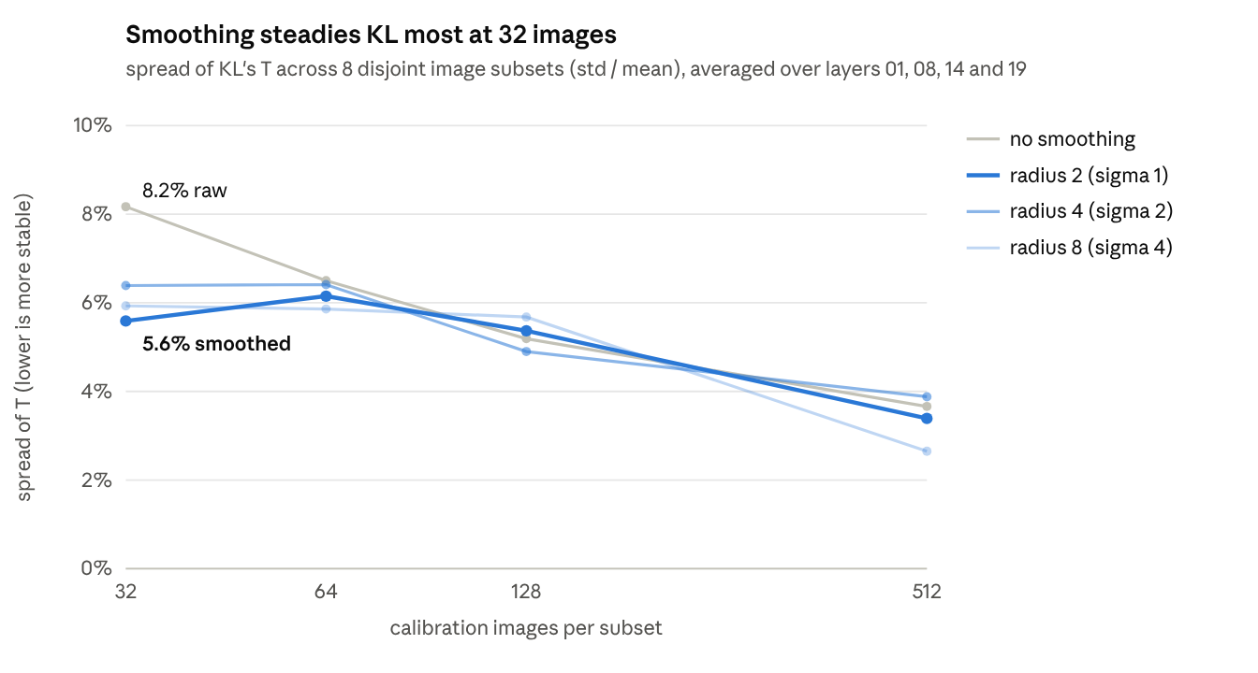
results/raw/smoothing.txt · 8 disjoint subsets per size from the 4,096-image export · Gaussian weights, sigma = radius / 2
Accuracy at 512 images, with T from the smoothed histogram:
Smoothing radius | KL accuracy (%) | MSE accuracy (%)
0 (off) | 91.82 | 91.77
2 | 91.89 | 91.71
4 | 91.80 | 91.71
8 | 91.76 | 91.78
Smoothing narrows KL's spread most at 32 images, from 8.2% to 5.6% at radius 2; from 64 to 512 images the change is under 1 point either way. Layer 19, with only 2,048 values at 32 images, gains the most: 8.7% to 4.7%. MSE barely moves at any radius (9.7% at 32 images either way), because it weighs the tail by squared error rather than by its shape. Smoothing also raises KL's T on most layers (layer 01: 5.24 to 6.29 at radius 4), since it spreads tail counts outward. Accuracy changes by under 0.2 points, within noise.

9. Conclusions
Both programs pick a layer's T in well under the time a CPU thread needs, and every INT8 method keeps ResNet-20 within 0.2 points of FP32.
- Best method: none measurably. KL and the 99.999th percentile tie at 91.82%, 0.19 points above max, but every method is within the 0.27-point noise of a 10,000-image test.
- What dominates P1: on the GPU, the passes over the data (0.076 of 0.126 ms on layer 01); on the CPU, the search (37 of 52 ms). On the small FC layer, fixed kernel-launch costs make up most of the GPU's 0.078 ms.
- Histogram versions: private shared-memory histograms were 22 to 58× faster than global atomics on the convolution layers. Warp-aggregating the zeros cost 4 to 8% instead of helping, because shared atomics on this GPU are already cheap.
- P2 against the model: it follows 1/p up to 16 ranks and reaches 18.0× on 22 cores, 20% below the model because the clock slows with all cores busy. Communication never exceeds 1.4% of the time and would overtake computation only near 700 ranks.
- Smoothing: it steadies KL at 32 images (spread 8.2% to 5.6%; layer 19, 8.7% to 4.7%), has no effect on MSE, and costs no accuracy.
Limits: every one-block step costs about 4 µs however little it does, so fixed costs dominate P1 on small layers. P2 ran on a single node, where messages are cheap; on a cluster with a real network, t_s would be far larger and the crossover much earlier.
Future work: keep m on the GPU so the host copy disappears, fuse the one-block steps into one kernel, process all 19 layers in one launch with streams, batch the allreduces, and repeat P2 across several nodes.

References
- Nagel, Fournarakis, Amjad, Bondarenko, van Baalen and Blankevoort. A White Paper on Neural Network Quantization. arXiv:2106.08295, 2021.
- Wu, Judd, Zhang, Isaev and Micikevicius. Integer Quantization for Deep Learning Inference: Principles and Empirical Evaluation. arXiv:2004.09602, 2020.
- He, Zhang, Ren and Sun. Deep Residual Learning for Image Recognition. arXiv:1512.03385, 2015.
- Krizhevsky. Learning Multiple Layers of Features from Tiny Images. Technical report, University of Toronto, 2009.
- Idelbayev. pytorch_resnet_cifar10, pretrained ResNet-20 checkpoint resnet20-12fca82f.th.
- NVIDIA TensorRT. IInt8EntropyCalibrator2 class reference.
- Sakharnykh. GPU Pro Tip: Fast Histograms Using Shared Atomics on Maxwell. NVIDIA Developer Blog, March 2015.
- NVIDIA. CUB (CCCL) documentation: BlockReduce, BlockScan, DeviceHistogram and DeviceReduce::ArgMin.

